# **Status Report May 2018**

# **The Status Report on “The Horticulture and Mushroom Value Chain Mapping and Analysis”.**

According of our planned work schedule, we have completed the survey phase and are now moving into the “Value Chain Analysis and Visualization” phase of this project, as seen in the chart below.

|  |  |  |  |  |  |  |  |  |  |
| --- | --- | --- | --- | --- | --- | --- | --- | --- | --- |
| Activity | Week 1 | Week 2 | Week 3 | Week 4 | Week 5 | Week 6 | Week 7 | Week 8 | Week 9 |

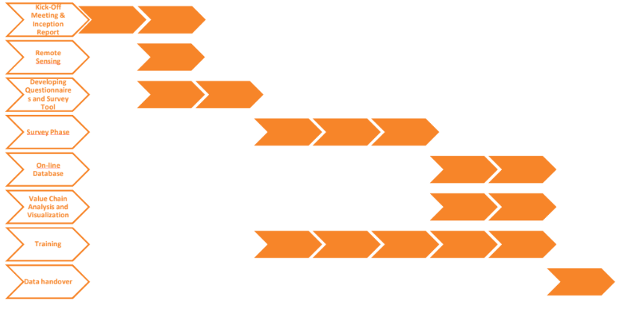

On 1st May 2018, the team tested out the data collection tool in Kyanja Parish, and the outcomes were used to improve the tool. The field data collection exercise in the targeted parishes has lasted for four (4) weeks, and the team has been able to collect data from the following actors along the value chains;-

* 8 Focus groups (38 farmers)
* 37 individual farmers
* 6 input suppliers
* 2 processors
* 4 consumers
* 3 traders
* 4 KCCA technical staff
* 1 FGD (6 farmers) from the test parish
* 3 Individual farmers from the test parish

**Data Collection Methodology**

The methodology included a combination of different approaches that allowed multidimensional data gathering. The team used a combination of data collection methodologies that included satellite-based approaches and geospatial data analysis, together with community based participatory data collection approaches.

1. The geospatial data analysis helped the team to categorize the parishes according to similarities using the parameters below; -

* Roof type of buildings
* Average age of citizens in the parish
* Population density
* Type of dwelling

By use of these parameters, the City was diveded into four (4) categories, and two parishes were selected from each category, totaling to 8 parishes from which data was collected. These eight parishes were randomly selected by the team, using a “Yes” card-pick method, by the team members.

1. The satellite-based approach was used to determine the amount of green space in Kampala in 2016 and 2018.
2. The Community Based Participatory Data Collection approach employed the use of Focused Group Discussion, Key Informant interviews and review of literature.
3. **Focus Groups**

* Margaret please add here (what consideration was made etc.)

Eight Focus group discussions were conducted for farmers from the eight target parishes that were chosen from the four divisions of Nakawa, Kawempe, Lubaga and Makindye. Central Division was excluded, due to its limited farming and residential activities. The selection of the Focus Groups was based on “purposive” and “convenience” sampling only for those farmers who were involved in either growing leafy vegetables or mushrooms. These were urban farmers, whom the community leaders thought would provide the research team with the information needed.

1. **Key informant Interviews**

Margaret please add here (what consideration was made etc.)

These targeted other actors in the value chain including;-

* *Individual farmers*

Within the categories of study, 5 farmers were randomly selected from each, with support from members of the respective FGDs, community leaders, input suppliers and traders. A total of 37 individual farmers were interviewed.

* *Other actors*

From the focus group discussion (FGDs) and Individual farmer interviews, other actors in the value chains were identified and purposely selected. These included Input suppliers, Processors, Traders, Consumers, KCCA technical staff and other service providers. A total of 19 key informant actors were interviewed.

From the Community Based Data Collection approaches, we have managed to collect a comprehensive dataset including agriculture production, processing, marketing, technology development & use, as well as regulatory related questions; Telephone contacts together with locations of where the focus groups discussion and individual farmers interviews were conducted were also collected. This data is expected to enable the start of creating a database of actors involved in urban farming value chains in the city.

From these two key methodologies (a) and (b) above the value chains of the leafy vegetables and mushrooms shall be mapped and analyzed.

* Margaret please add here: Definition of value chain mapping as defined by WFP document and how this supports our methodology (We are trying to support our methodology in mapping of a value chain)

It’s important to note that;-

Value Chain Mapping is a process that identifies the main activities associated with a given commodity or a product line. It does not necessarily represent data in a geographical way, but more in a way that represents processes and flows from e.g. farmer to consumer. The term denotes a process comprising several related steps, where each step, adds a value to the product or helps it to continue to its next step. It gives a visual representation and understanding of processes and value added to a given product or workflow.

According to the Terms of Reference, the study was expected to undertake;-

1. An Urban Agricultural value chain Mapping, and

ii. A Horticulture crops (including mushrooms) value chain analysis

However, due to modification in the Budget (funding constraints of the part of KCCA), the scope of services to be delivered as part of the project was also reduced. (See communication and work plan submitted in January 2018, herewith attached).

Therefore, the focus of the study has mainly been centered on value chain analysis of Horticulture crops (including mushrooms); and for purposes of this study, Value chain mapping and analysis has been used as a strategy to identify commodity performance gaps, constraints and improvement opportunities.

Based on this and the meetings that we have had with KCCA, it has become evident to us that this data collection process is aimed at providing insight into what is happening in the city as far as Horticulture (including mushrooms) is concerned. The findings of this process will then aid planning on the side of KCCA.

# **Next step:**

The survey phase of this project is complete and as such the data analysis part of the project is starting. During this phase we expect to create the products that we will hand over at the end of the project. There are 2 main products that will be handed over, a report and an online web map. The outline for the report will be shared as soon as it is done.

## **Data collected and its value:**

Quantitative and Qualitative data was collected using KoBo-collect online toolbox, on functional, social and economic dimensions of the two value chains. Currently the data collected is still being cleaned and Data analysis is due to begin on 4th June 2018

## **Online map and database:**

The online web map on the other hand will have information on the amount of green space that exists in each parish along with the findings of the focused group discussions in the parishes where they were conducted (Kasubi, Mulago 1, Kazo Angola, Makindye 1, Kikaaya, Ntinda, Salaama, Busega). The data collected on individual farmers and other players in the value chain may also be displayed in this web map depending on what trends can be identified from the data.

We hope to continue this way and complete the project within the previously discussed time. However, additional work like adding data from the WFP project will be discussed as part of the data handover.

## **Training**

We have completed one training at KCCA. The training was done Monday, 28th May. The training gave an insight in the data that was collected and how it was done. Question as raised, which will be taking into consideration for the next training. We are aiming to have the next training within 2 weeks. The exact date will be discussed with KCCA.